Michael | I thought maybe we could talk about the concept of “High-tech Orientalism,” through Robot Stories and some additional examples. Here are a few examples that I thought would challenge and complicate the concept. 1) Meet Dave (2008) http://www.youtube.com/watch?v=JAVUsrEQPBQ&feature=fvwrel. In this film Eddy Murphy plays two characters a human sized mecha and the smaller in size captain. 2) The improvised Asian extra in science fiction film and television, like Firefly and Blade Runner. These shows have a major disproportion between the number of Asian extras and Asians speaking characters. http://www.youtube.com/watch?v=fZr9wsZz_bk. 3) What about the Marvel superhero the Black Panther. http://marvel.com/videos/watch/505/black_panther_comic_book_trailer. The Black Panther is from the “worlds most technologically advanced nation, Wakanda. Wakanda is a fictional African nation-state in the Marvel Universe. If the Superhero narrative is also a utopian narrative, than what does it mean to place this tech-utopian, Western narrative in a fictional African context. 4) Boomer from BSG.
Pedro | I’d like to delve deeper into the first half of the Chun piece. Specifically, I was struck by the way that she traced the changing ways that race operated as a technology in enlightenment vs. modern epistemes (from natural history to biology, which is from the Order of Things), and the way that she connected it an “epistemology of visibility” that creates a gap between “what he body says and what the body does” (40-44). That this gap doesn’t interrupt “racial thinking,” but, as Stoler (quoted by Chun) argues, creates “conditions for its proliferation and possibility” seemed like a rather profound, if dense, point. How does this compare, for example, with the (much more common) critique of “racial thinking” through the lens of essentialism, naturalization, reification, etc.?
Jalynn | In Fouche’s “One Laptop Per Child”, the article is a misrepresentation of race and technology. The discus discussion of black engineers and inventors skims over their accomplishments without mentioning the direct contribution of their innovations. Fouche states “For example, many African-Americans patented inventions, like those that improved railway transportation, which at best only partial benefited African-Americans, and at worst, contributed to the maintenance of racial segregation” pg 68.  ......................In 1923 an African American by the name of Garret A. Morgan “[He] was the first to patent a three..............way automatic traffic signal. He sold the patent to General Electric.” Black Firsts, Jessie Carnay...........Smith, Visible Ink Press: Detroit, 2003 (pg 496).  ......................I think Mr. Morgan’s invention was a contribution. And contrary to what Fouche believes, West .......................Africans were blacksmiths and metal workers before slavery. In fact, their skills contributed .......................to the beginning of slavery for Africans in the new world.  ........................”However, these new and quickly reproduced images of blackness assisted in the condensing.....  ........................multiple protests into one dominant televised event: the “March on Washington.” Similarly Martin...............Martin Luther King Jr. has been condensed to sound bites from his “I have a Dream” speech............speech in 1963. Unfortunately, it also condemns king’s life to end in 1963 and overlooks his other................other ideas, particularly his writing about science and technology in his last published book..................book in 1968, Where do We Go From Here?” (Fouche pg 70).  .........................I would like to point out an error concerning information about Martin Luther King Jr. The Civil  ..........................Rights Act of 1964 came about as result of Martin Luther King Jr. and he was assasinated  ......................in 1964. He was an amazing speaker, and the technology of television and radio more accurately  ......................captured his ability and the attention of the world.
Dan | Chappell's peice on Low Riders as a raically encoded object is facinating to me along two lines that I will try to draw out. First, in terms of appropration of technology by working class people, it is interesting to demonstrate that simultaniously to a working class, white culture of cars (Hot Rods, Rat Rots, Rockabilly, Etc) there is a working class latino culture related to cars sharing similar, though unique building characteristics. There are certainly cars that might slip between both words as Chappell points out that the coventions that would work within hot rods (smooth shapes, frenching, modeling, custom cars over prebought etc.) are also welcome in low riders but that exchange goes one way, not two. Inside of American car culture, there are two different counter-cultural approaches to developing cars. What does this say about the flexablity that working class skilled labor has for developing it's own technology of expression when divided along racial/ethinic lines? It would seem that drawing boundaries or rules about 'what counts' is productive for generating many types of expression underneath those rules, but what does positioning the group as counter to the dominant frame do in terms of generating new ideas instead of just reproudcing ideas? Secondly, I think there is something interesting going on in terms of this miniture, giantic distinction that is shown as a kind of fantasy play on one hand and a carnival like play on the other. The ideas that it is rooted in older cultural practices into the Spanish is facinating, but to what extent are we talking about the play with scale as also being just a form of rejection of cultural norms of standarization which area also part of car culture broadly in the US?
Colin | The Fouche piece, “From Black Inventors to One Laptop per Child,” presents a challenging view of slavery-as-technology, and the construction of African-American identity through the development and evolution of technoscientific systems in America. Interestingly, when race-as-a-technology of the self began to lose reality in Science, it was increasing in reality with African-Americans and other minority groups, and coming to a head in the Civil Right movement, complicating any naive conceptions of the role race plays in society. The naivete of dominant, white, technoscientific culture is further problematized by Fouche when he takes aim at the OLPC program, a program that rich, white members of the middle-class were taking part in with, ostensibly, the best of intentions--regardless of the popularity of netbook spinoffs. Thanks to Fouche, we can extend our self-reflexivity even further, so far as to question the “philanthropic urge” and the intentions that might lie just beneath the surface.
Ellen | I definitely find Chun’s idea of Race as Technology very intriguing. As she states race as technology, “displaces claims of race as either purely biological or purely cultural because technological mediation, which has been used to define humankind as such..is always already a mix of science, art and culture.” (39)  She also poses the question: “to what extent can ruminating on race as technology make possible race as poiesis or at least as a form of agency? Can race become a different mode of creation or revealing? Race has historically enabled subversive action.” (49)  I wonder how her theory and these particular questions might relate to the piece on Low-rider culture and technology. So from seeing race as technology, low-riders are bringing their culture to the technology. There is definitely a personal identification with the low-rider cars and an extension of self within the modifications. Low-riders state, “[t]his is ours. This is what we started. This is what we do.” And “That’s what it’s about: expressing our culture.” (102) Thus, they are subversively utilizing and modifying an established technology to reaffirm identity.  I’m also a little curious about the Gigantic and the Miniature dichotomy and the meaning behind that. Footnote # 29 goes into a little deeper meaning and background within Western culture.
db |   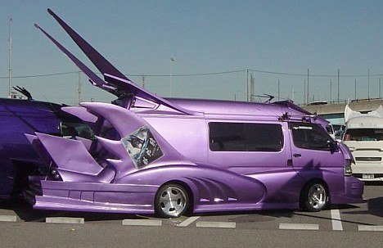  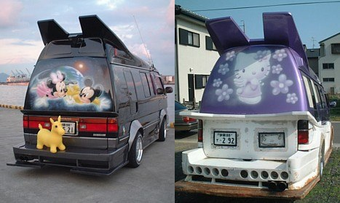  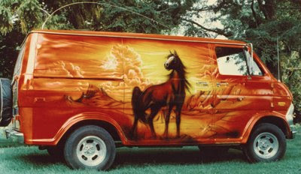  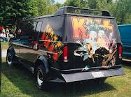  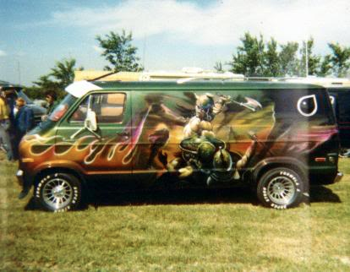  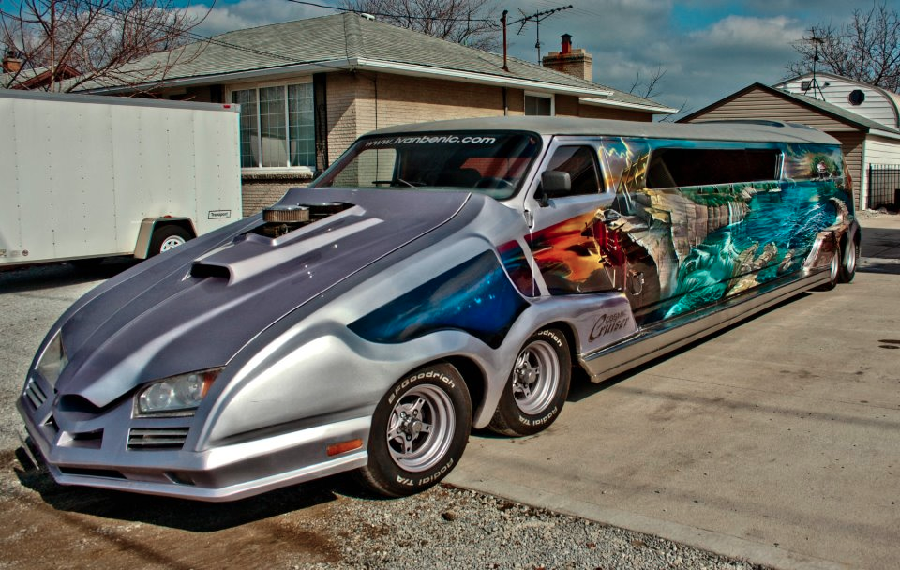  Fouche brings up some excellent points about the digital divide. Namely, "These programs [OLPC] driven by the 'if only they had…' mantra, adly, though not purposefully, construct the receivers of these technological tools as empty vessels into which Western technological knowledge must be poured." What would an alternative "two-way bridge" look like? Who initiates the building of the bridge? How do we create new technologies while also recognizing (and addressing) the concerns held by the government of Nigeria and others. Namely, our students need to learn how to use the dominant information technologies of the global economy, and not a child-like "open" operating system that does not provide pragmatic skills needed for post-industrial work. “A developed country is not a place where the poor have cars its where the rich ride the bus.” -Mayor of Bogota    

